**LAB ASSIGNMENT-03**

* To find Largest of Three Numbers

**#!/bin/bash**

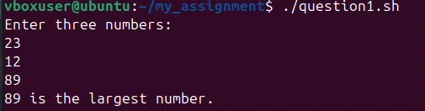

**read -p "Enter first number: " a**

**read -p "Enter second number: " b**

**read -p "Enter third number: " c**

**if (( a >= b && a >= c )); then**

**echo "$a is the largest."**

**elif (( b >= a && b >= c )); then**

**echo "$b is the largest."**

**else**

**echo "$c is the largest."**

**Fi**

* To find a year is leap year or not.

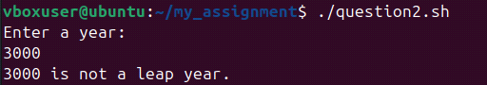

**#!/bin/bash**

**read -p "Enter a year: " year**

**if (( (year % 4 == 0 && year % 100 != 0) || (year % 400 == 0) )); then**

**echo "$year is a leap year."**

**else**

**echo "$year is not a leap year."**

**Fi**

* To input angles of a triangle and find out whether it is valid triangle or not
* 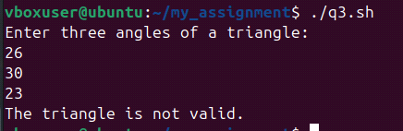

**#!/bin/bash**

**read -p "Enter angle1: " a**

**read -p "Enter angle2: " b**

**read -p "Enter angle3: " c**

**sum=$((a + b + c))**

**if (( sum == 180 && a > 0 && b > 0 && c > 0 )); then**

**echo "Valid Triangle"**

**else**

**echo "Invalid** Triangle"

**fi**

* To check whether a character is alphabet, digit or special character.

**#!/bin/bash**

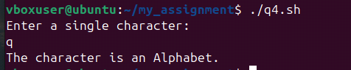

**read -p "Enter a character: " ch**

**if [[ $ch =~ [A-Za-z] ]]; then**

**echo "Alphabet"**

**elif [[ $ch =~ [0-9] ]]; then**

**echo "Digit"**

**else**

**echo "Special Character"**

**fi**

* To calculate profit or loss

**#!/bin/bash**

**read -p "Enter cost price: " cp**

**read -p "Enter selling price: " sp**

**if (( sp > cp )); then**

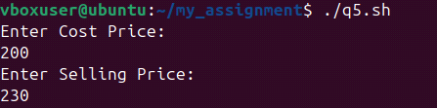

**echo "Profit of $((sp - cp))"**

**elif (( sp < cp )); then**

**echo "Loss of $((cp - sp))"**

**else**

**echo "No Profit No Loss"**

**fi**

* To print all even and odd number from 1 to 10

**#!/bin/bash**

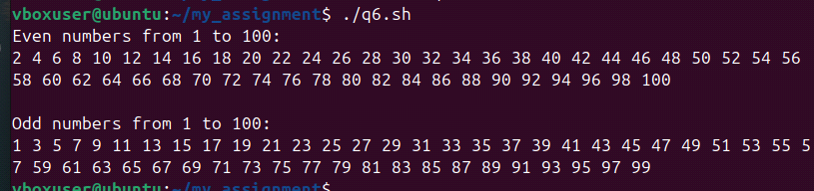

**echo "Even numbers:"**

**for i in {1..10}; do**

**if (( i % 2 == 0 )); then**

**echo -n "$i "**

**fi**

**done**

**echo -e "\nOdd numbers:"**

**for i in {1..10}; do**

**if (( i % 2 != 0 )); then**

**echo -n "$i "**

**fi**

**done**

echo

* To print table of a given number

**#!/bin/bash**

**read -p "Enter a number: " n**

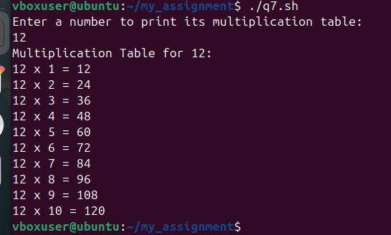

**for i in {1..10}; do**

**echo "$n x $i = $((n * i))"**

**done**

* To find factorial of a given integer

**#!/bin/bash**

**read -p "Enter a number: " num**

**fact=1**

**for ((i=1; i<=num; i++)); do**

**fact=$((fact * i))**

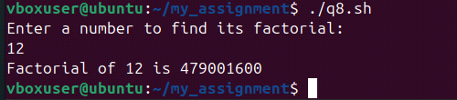

**done**

**echo "Factorial of $num is $fact"**

* To print sum of all even numbers from 1 to 10.

**#!/bin/bash**

**sum=0**

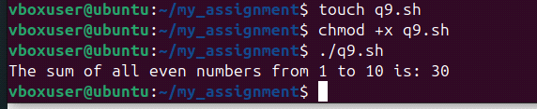

**for i in {1..10}; do**

**if (( i % 2 == 0 )); then**

**sum=$((sum + i))**

**fi**

**done**

**echo "Sum of even numbers from 1 to 10 is $sum"**

* To print sum of digit of any number.

**#!/bin/bash**

**read -p "Enter a number: " num**

**sum=0**

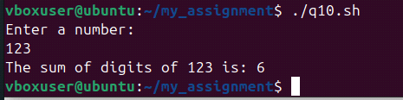

**while (( num > 0 )); do**

**digit=$((num % 10))**

**sum=$((sum + digit))**

**num=$((num / 10))**

**done**

**echo "Sum of digits is $sum"**

11. To make a basic calculator which performs addition, subtraction, Multiplication,

Division

**#!/bin/bash**

**echo "Enter two numbers:"**

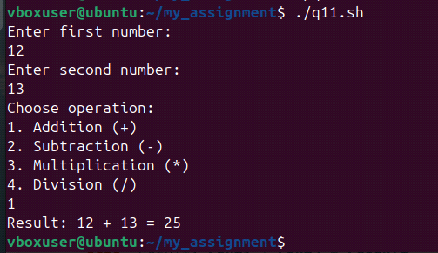

**read a**

**read b**

**echo "Choose operation: + - * /"**

**read op**

**case $op in**

**+) echo "$a + $b = $((a + b))" ;;**

**-) echo "$a - $b = $((a - b))" ;;**

**\*) echo "$a * $b = $((a * b))" ;;**

**/) echo "$a / $b = $((a / b))" ;;**

**\*) echo "Invalid operation" ;;**

**Esac**

* To print days of a week.

**#!/bin/bash**

**days=("Sunday" "Monday" "Tuesday" "Wednesday" "Thursday" "Friday" "Saturday")**

**for day in "${days[@]}"; do**

**echo "$day"**

**done**

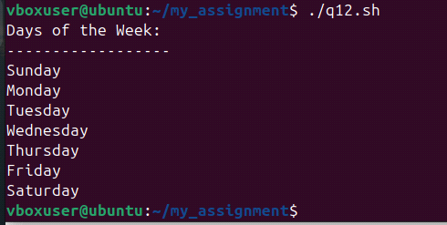

13. To print starting 4 months having 31 days.

**#!/bin/bash**

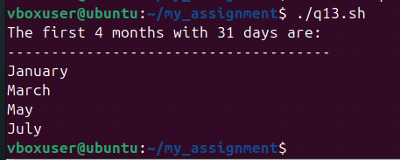

**months=("January" "March" "May" "July")**

**echo "Months with 31 days:"**

**for month in "${months[@]}"; do**

**echo "$month"**

**done**

14. Using functions,

**a. To find given number is Amstrong number or not**

**#!/bin/bash**

**is_armstrong() {**

**num=$1**

**sum=0**

**temp=$num**

**while (( temp > 0 )); do**

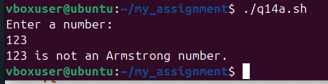

**digit=$((temp % 10))**

**sum=$((sum + digit * digit * digit))**

**temp=$((temp / 10))**

**done**

**if (( sum == num )); then**

**echo "$num is an Armstrong number."**

**else**

**echo "$num is not an Armstrong number."**

**fi**

**}**

**read -p "Enter a number: " n**

**is_armstrong $n**

b. To find whether a number is palindrome or not

**#!/bin/bash**

**is_palindrome() {**

**num=$1**

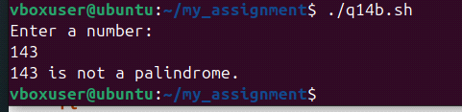

**rev=0**

**temp=$num**

**while (( temp > 0 )); do**

**digit=$((temp % 10))**

**rev=$((rev * 10 + digit))**

**temp=$((temp / 10))**

**done**

**if (( rev == num )); then**

**echo "$num is a palindrome."**

**else**

**echo "$num is not a palindrome."**

**fi**

**}**

**read -p "Enter a number: " n**

**is_palindrome $n**

c. To print Fibonacci series upto n terms  
**#!/bin/bash**

**fibonacci() {**

**n=$1**

**a=0**

**b=1**

**echo "Fibonacci series up to $n terms:"**

**for (( i=0; i<n; i++ )); do**

**echo -n "$a "**

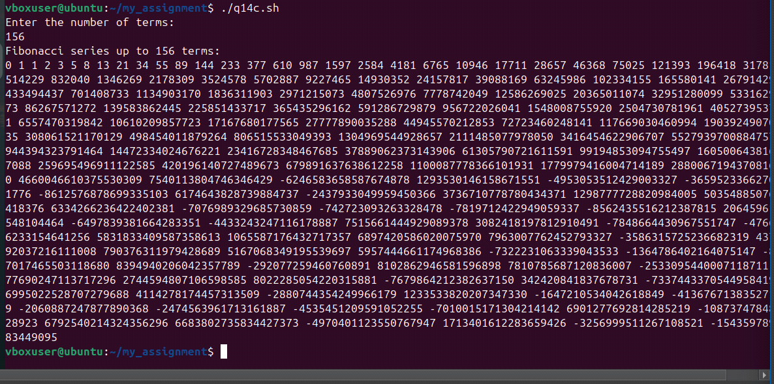

**fn=$((a + b))**

**a=$b**

**b=$fn**

**done**

**echo**

**}**

**read -p "Enter number of terms: " n**

**fibonacci $n**

d. To find given number is prime or composite

**#!/bin/bash**

**is_prime() {**

**num=$1**

**if (( num <= 1 )); then**

**echo "$num is neither prime nor composite."**

**return**

**fi**

**for (( i=2; i*i<=num; i++ )); do**

**if (( num % i == 0 )); then**

**echo "$num is composite."**

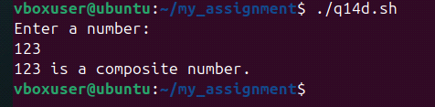

**return**

**fi**

**done**

**echo "$num is prime."**

**}**

**read -p "Enter a number: " n**

**is_prime $n**

e. To convert a given decimal number to binary equivalent

**#!/bin/bash**

**decimal_to_binary() {sz**

**num=$1**

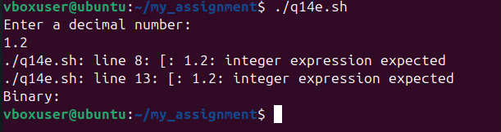

**binary=""**

**while (( num > 0 )); do**

**binary=$((num % 2))$binary**

**num=$((num / 2))**

**done**

**echo "Binary: $binary"**

**}**

**read -p "Enter decimal number: " n**

**decimal_to_binary $n**